Meeting 20
Course / Class #: CECS 4800

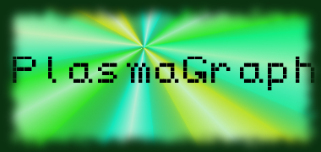
Date: 20 February 2014
Project Name: PlasmaGraph
Has been done:
1) Unit Testing: Added additional tests to CSV testing, and fixed certain bugs that appeared as a result of said tests. (CSV reading not providing correct data, or interpolation not providing images.)
2) Additional changes to GUI-related classes. (Added “Group By Experiment” Check box; added connections to template “group_by” setting.)
3) Work on the Matlab Data Reading. (Fixed some errors regarding varying column lengths and null values.)
4) Meeting with client.
a) Showed images of proper interpolation curves (Linear, Quadratic, Cubic, Quartic, and Spline Interpolations.) and GUI. (All tabs and main view.)
b) Presented the procedure we'll be taking to create the Outlier Scanning. (Automation via Mahalanobis Distances.)
c) Received request for “Group By Experiment” option.
d) Received request for demo presentation (for him) and product explanation presentation. (for him and PUPR Plasma Laboratory students.)

What will be done:
1) Outlier Search via Mahalanobis Distances (and respective tests) will be implemented.
2) Create Matlab Reader, Outlier Search, and general GUI tests.
3) Interface Readers into program. Interface reading of multiple files
4) Try to present demo to Client by end of next week.

Materials Used: 2x Computers, Internet connections, Microsoft Visio / Dia (Diagramming Tools), Eclipse / NetBeans IDE (Programming Tools).

Group Members: ________________________________
Gerardo A. Navas

________________________________
Daniel Quintini
Professor:

________________________________
Prof. Luis A. Ortiz

